CSS

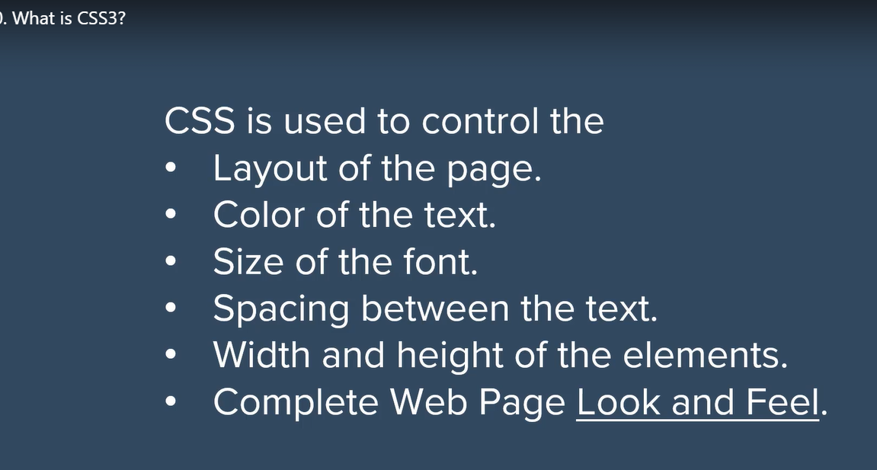

Syntax:

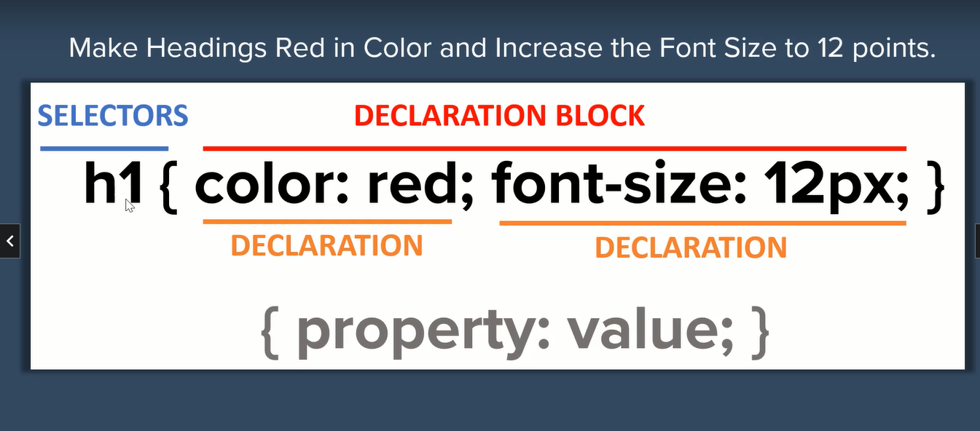

Inline CSS: -

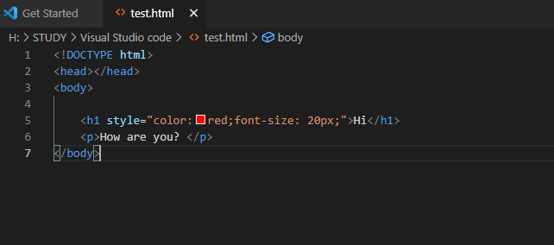

Comments:- css comment will be written in between style tag.

If it is written in outside of style it will consider as html comment

Css comment: /\* css comment \*/

Html comment: <!-- html Comment -->

<Link> -tag is used for external css

Linking multiple css: -

